Chapter 9: MCU Peripherals

1. Describe the operation of watchdog timer. (4 scores)

A watchdog is a hardware timer used to detect and recover microcomputer malfunctions (due to noise, bugs, etc…).

During normal operation, the microcomputer regularly restarts the watchdog timer to prevent it from elapsing, or "timing out". If there is hardware fault or program error, the microcomputer cannot restart the watchdog timer. This timer will elapse and generate an interrupt signal.............................................................................................................................................................

........................................................................................................................................................................

2. About RL78/G14, what is the value of activation key? (2 scores)

a. 0xFF b. 0xAB c. 0xAC d.0xEF  
-> C

3. Which value of Option Byte can disable watchdog operation?(4 scores)

a. 0xFFFFFF b.0xEFFFF8 c.0x2EFFFF8 d.0xF0EFF8  
**-> C**

4. Complete the following statement.(12 scores)

Converting an analog signal like temperature sensor into a digital value is called ..(1)... For the conversion method of ..(1).., the way to determine the converted data bit-by-bit while comparing with input voltage is called ..(2)...

Since the analog signal is consecutive, it is impossible for digital number express it in one-to-one relationship. Therefore, you should understand there is some ..(3).. contained in the converted value. The feature of ..(4).. describes a performance of ..(1)... If the performance is improved, the conversion time will be increased, but ..(3).. can be reduced.

(1) A-D converter

(2) Successive approximation

(3) Conversion error

(4) Resolution

5. Provide the voltage source for A-D converter in RL78/G14. (9 scores)

- Internal reference voltage (1.45V)

- VDD

- AVREFP or AVREFM .............................................................................................................................................

........................................................................................................................................................................

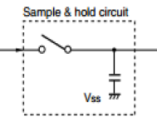6. Draw the Sample and Hold circuit of Rl78/G14 and provide the purpose of this circuit. (6+4 scores)

........................................................................................................................................................................

........................................................................................................................................................................

........................................................................................................................................................................

........................................................................................................................................................................

7. Complete the following statement (27 scores)

In the data communication, using multiple signal line to transfer multiple bits simultaneously is called ..(1).. communication, transferring data bit-by-bit is called ..(2).. communication.

The value of data can be known from the level ‘H’ or ‘L’ of the signal line. The receiving side needs to inform when the level ‘H’ or ‘L’ implies a value of data. At this timing, the sending side will transfer the data according to the created clock signal. This communication way is called ..(3).., rather than ..(4)..

When using ..(4).. communication method, it is necessary to fix the data format and ..(5).. between the sending and receiving side in advance. This data format begins with ..(6).. that indicates the head of the data and the data length, parity but, as well as ..(7).. that indicates the end of the data, etc. The receiving will be stared as soon as ..(6).. is detected out, and all data will be received one-by-one on the data format and ..(5).. At that time, if there is mistake detected with parity bit, it is ..(8).. error; if ..(7).. cannot confirm correctly, ..(9).. error will be detected.

1. parallel 6. start bit

2. serial 7. stop bit

3. asynchronous 8. Parity

4. Clock asynchronous 9. Framing

5. transfer rate

8. Draw an I2C bus includes: a master and a slave. (8 scores)

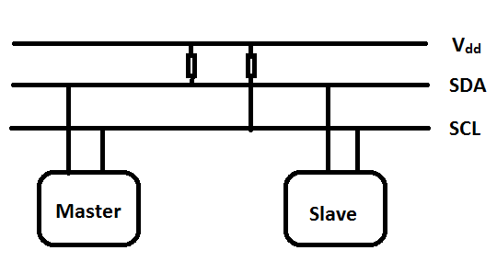

9. Mapping the keyword in the left side with its definition in the right side. (12 scores)

|  |  |
| --- | --- |
| 1. Start signal | a. At the 9th clock pulse after transmission, the SDA level is at Low level. |
| 2. Stop signal | b. Serial data line |
| 3. SDA | c. At the 9th clock pulse after transmission, the SDA level is at High level. |
| 4. SCL | d. A Low to High transition on the SDA line while SCL line is High. |
| 5. Ack signal | e. Serial clock line |
| 6. Nack signal | f. A High to Low transition on the SDA line while SCL line is High. |

1.f..... 2..d... 3.b.... 4..e... 5..a.... 6..c...

10. Draw a SPI bus includes a master and 2 slaves (Slaves are controlled by individual SS pin). (8 scores)

11. Explain why SPI is a full-duplex communication. (4 scores)

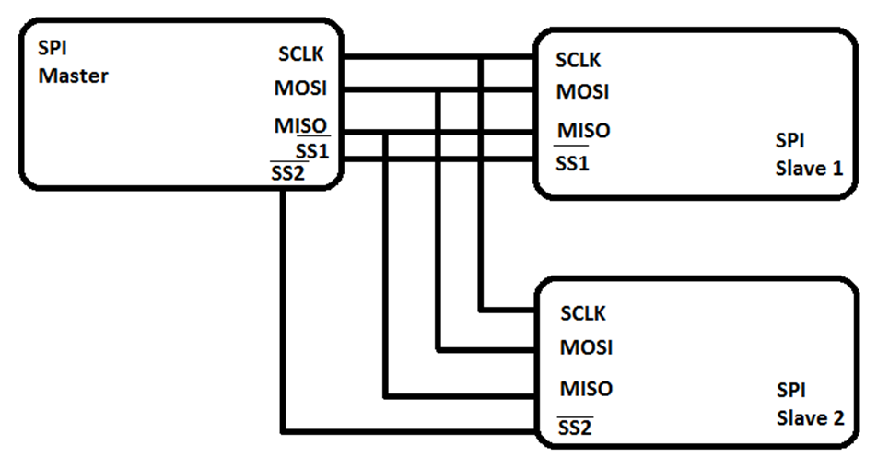

Because allowing communication in both directions

........................................................................................................................................................................

........................................................................................................................................................................

........................................................................................................................................................................

Addition Question

1. Open ttermpro.exe and choose Serial and choose Port you want to connect (you can choose again by Setup -> General Setting.

To use UART, you must to setup some parameter such as: Port, Baud rate, Data, Parity bit, Stop bit, Flow control, you can setup Transmit delay too.

Definition of parameter:

Port: Serial port to be used.

Baud rate, Data, Parity, Stop, Flow control

Transmit delay: Time intervals between characters (lines) being sent, in milliseconds.

1. UART error:
   1. Parity error: A parity bit is a bit added to the end of a binary code. In case of even parity, if the total number of “1” of the original code is odd, the parity bit value is set to “1” so that the total number of “1” of the binary code (including the parity bit) becomes even. A parity error occurs when the parity of the total number of “1” is different from that specified by the parity bit.
   2. Overrun error: This error is generated when the next data lines up before the content of receiving buffer register is read.

Framing error: This error is generated when stop bit falls short of the set number of stopbits.